

**LEARNING RESOURCE CENTRE**

**(LIBRARY)**

#### OUR MISSION

#### SERVE THE USERS EFFECTIVELY AND

EFFICIENTLY WITH ALL COURTESY AND SMILE

###### **KENDRIYA VIDYALAYA NO.2 JHANSI CANTT**

###### **AGRA REGION**

###### 

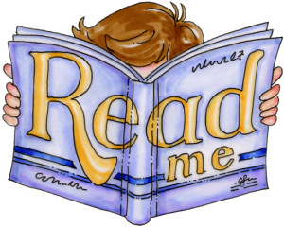

Books are every country’s weapon, without which the country is weak.  
Books are like the sun’s light and they help people rise themselves.  
Books are precious treasure and best friends of people. “

“Books are the mirrors of the world  
Books are the mirrors of the life  
they are the biggest treasure  
that we could find in our hearts.

 ‘Books are like the sun’s light and they help people raise themselves

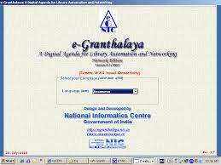

e-Granthalaya

e-Granthalaya is a Library Management Software developed by National Informatics

Central Ministry of Electronics and Information Technology, Government of India.

e-Granthalaya is useful for automation of in- house activities of libraries and to

Provide various online member services.

The Software provides built-in Web OPAC interface to publish the library catalog over Internet.

The software is UNICODE compliant thus, supports data entry in local languages

The library of Kendriya Vidyalaya K.V.No 2 Jhansi Cantt with its excellent collection of books, periodicals and multimedia and a variety of services, acts as a support and inspiration to the teaching and learning community of the School.

**Mission**

The Library provides a welcoming learning environment for students and staff; supports the school’s aims and curriculum; encourages the love of reading and the development of students’ independent learning skills.

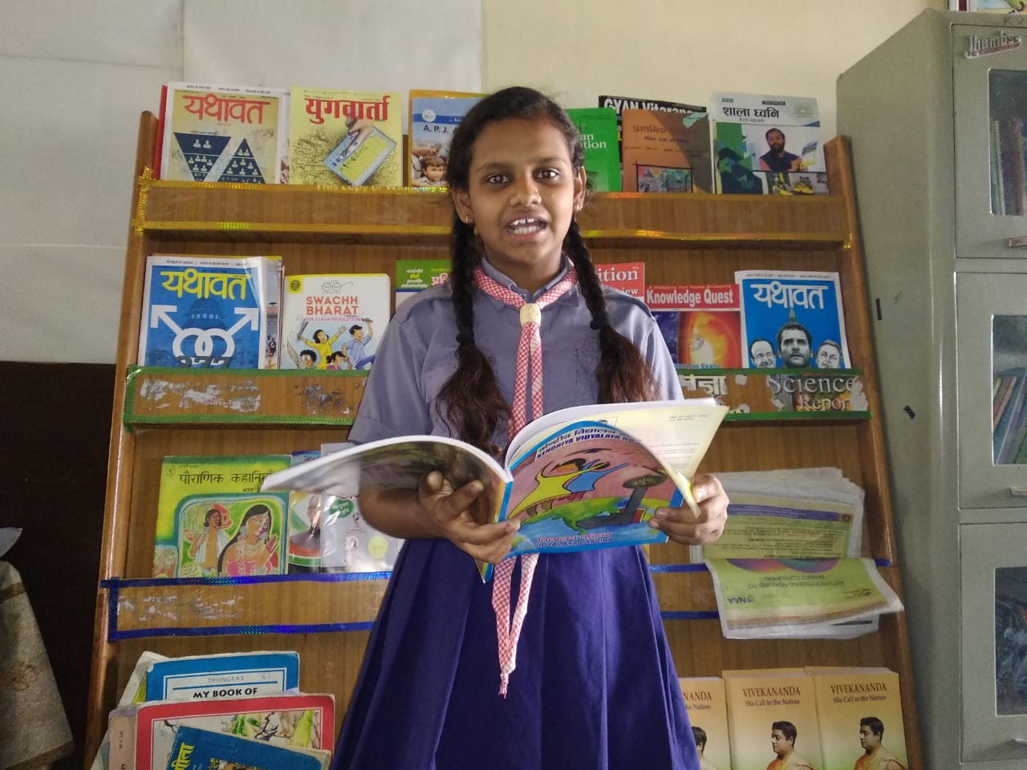 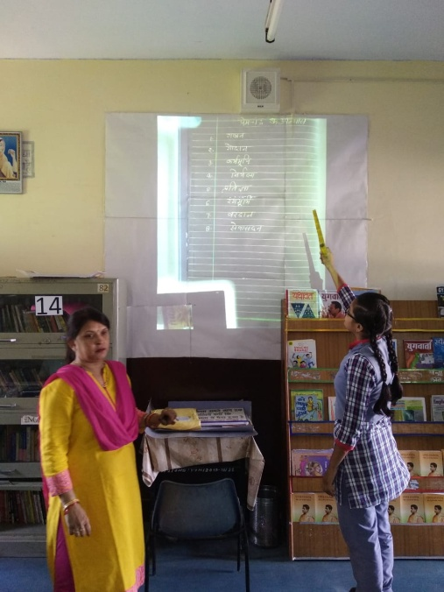

Our Vidyalaya library’s details.

Total collection- 7585

Hindi books- 3824

English books- 3379

Reference books- 382

Hindi book English book

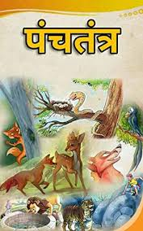 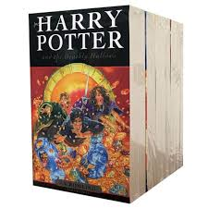

Reference books

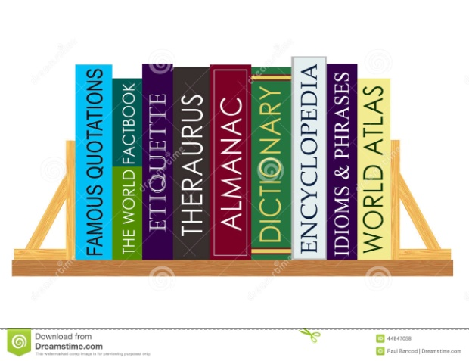



**The following activities/services are providing through e-Granthalaya:**

* **Retro – conversion for direct data entry of books in a single form.**
* **Issue – return**
* **Library blog**
* **Library statistics**
* **Budget modules with bill register generation**
* **Data entry statistics**
* **Stock verification**

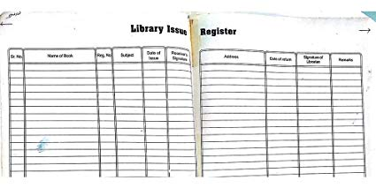

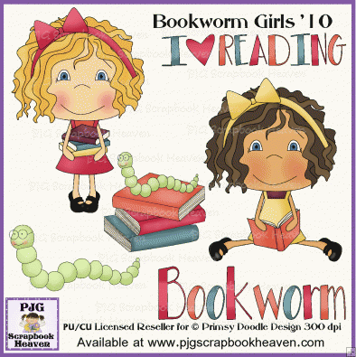

**“**A book is the only place in which you can examine a fragile thought without breaking it, or explore an explosive idea without fear it will go off in your face. It is one of the few havens remaining where a man’s mind can get both provocation and privacy.**”**

– Edward P. Morgan